
 |  |  | 
 |  |  | 

Final report of the Specific Contract 1 (SC1)
First version of EFDAC E-forest platform

“Framework contract for the provision of forest data and services in support to the European Forest Data Centre”
Reference: 2007/ S 194-235358 of 09/10/2007

Contents

1 The Framework context 4
2 The EFDAC E-forest platform 5
2.1 Objective 5
2.2 Description of EFDAC E-forest platform infrastructure 5
2.2.1 Overview 5
2.2.2 Software architecture 5
2.2.3 Layers provided by the JRC 6
3 EFDAC E-forest platform: Specific Contract 1 7
3.1 Main functionalities and goals 7
3.2 Database descriptions 8
3.2.1 Overview 8
3.3 Main modules 8
3.3.1 Modules description 8
3.3.2 Authentication module 8
3.3.3 Data gathering module 9
3.3.4 Data query builder 10
3.4 Follow up of the project, contractual steps 13

List of figures
Figure 1: Consortium's platform modules 5
Figure 2: Software architecture 6
Figure 3: SC1: consortium's platform 7
Figure 4: Authentication module 8
Figure 5: Data gathering module 9
Figure 6: check report 10
Figure 7: data query builder screenshot 11
Figure 8: data query builder, table result 12
Figure 9: data query builder, map result 13

The Framework context

The objective of the framework contract is to broaden and develop the knowledge base of the European Forest Data Centre (EFDAC) hosted by the Joint Research Centre (JRC)1 of the European Commission which has been established to supply European Union decision-makers with processed, quality checked and timely policy relevant forest data and information within the EU and territories where EU policies are operating.
The EFDAC will be developed and implemented as the single and central point for forest information at European level in support to relevant EU policies and as the basis of the European Forest Monitoring System proposed in the EU Forest Action Plan. The implementation of EFDAC will contribute to enhancing data harmonization and to streamlining data collection and reporting to international commitments such as the Ministerial Conference of the Protection of Forest in Europe (MCPFE), the FAO Global Forest Resources Assessment (GFRA) and the UN Convention on Biological Diversity (CBD). EFDAC will be built on the basis of the information systems currently existing or under development and in compliance with the guidelines of the Infrastructure for Spatial Information in Europe (INSPIRE). In particular, these systems are the European Forest Fire Information System (EFFIS), the Forest Focus Data Platform, and the European Forest Information and Communication Platform (EFICP). New methods and tools developed for forest and natural hazards monitoring (forest fires, storms, etc) will decisively contribute to the further development and implementation of the Global Monitoring for Environment and Security (GMES) initiative.

Thus, the framework contract will include the provision of the following services or data at EU level:
- technical assessments such as reports, models, reviews, etc.
- data in the form of either statistics from forest inventory data (e.g. spatially aggregated plot data to provide harmonized estimates of selected indicators/attributes for given areas) or selected plot attributes derived from plot observation/measurements (e.g., forest type, growing stock), to be used as validation or training fields for map production or modeling..

Before providing these services, a platform called EFDAC E-forest platform is required.

The EFDAC E-forest platform

Objective
To provide the required services within the framework contract, a platform called “EFDAC E-forest platform” is needed. This platform is useful for all consortium’s partners to upload required raw data in response to a JRC request, harmonize them at an European level and transform them into aggregated data, spatial representation, maps, etc.
This platform can be considered as the central working area for the consortium’s members and acts as an intermediary system between the data providers and the EFDAC.

Under the framework contract, the first two Specific Contracts concern the building of EFDAC E-forest platform.
The first Specific Contract corresponds to the building of the EFDAC E-forest platform to perform raw data upload, storage and queries based on a central metadata base.
The second Specific Contract corresponds to an enrichment to run specific processes or perform treatments such as harmonization, aggregation, spatial representation, dissemination to EFICP.
The picture below shows the main modules by distinguish SC1(plain), SC2 (Hatched) and SC? for further developments.

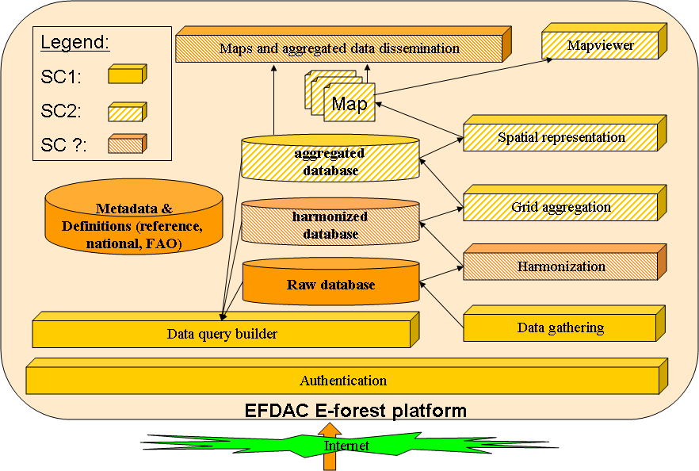
Figure 1: Consortium's platform modules

Description of EFDAC E-forest platform infrastructure

Overview

The EFDAC E-forest platform is developed by the French National Forest Inventory (FNFI) and hosted by the FNFI.
In order to reduce the cost of this platform, numerous modules come from other applications developed by the FNFI.
All the core or main components are based on Open source software.
The source code developed under this project is provided with the European Public Licence.

Software architecture
The following figure shows the software infrastructure

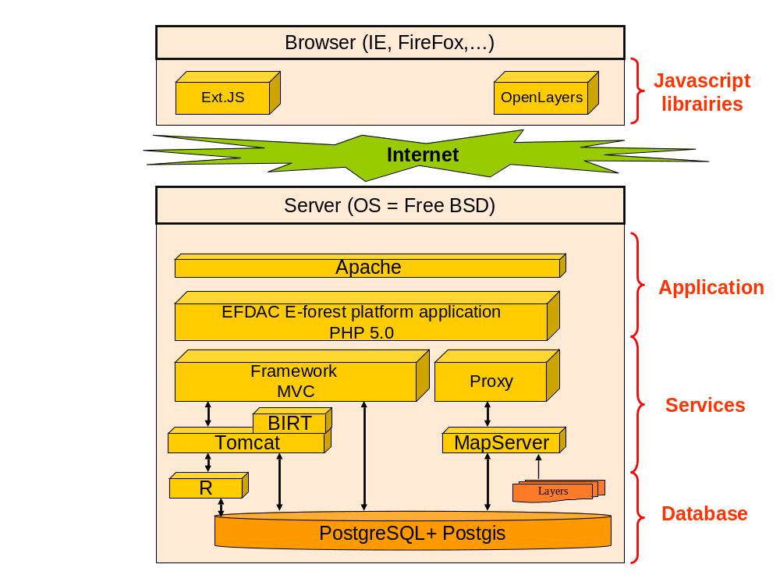
Figure 2: Software architecture

The server Operating System is Free BSD ( http://www.freebsd.org ).
The web server application is based on Apache ( www.apache.org/) and Tomcat (http://tomcat.apache.org/ ) .
The application is developed using PHP and Java languages in order to be independent from the operating system.
PHP is a very mature and powerful language. PHP Web servers are robust and can be developed in a very short time.
A PHP framework is used to ensure the good respect of the Model View Controler design pattern which corresponds to a separation of the database accesses, the management of the user behavior and the web based user interface.
JAVA is useful for the data integration module and any special treatment such as harmonization process. Java is also used to establish an interface between the application and R (see below).

Mapserver (http://mapserver.gis.umn.edu/) is used to provide OGS services such as Web Map Service, Web Feature Service
BIRT(http://www.eclipse.org/birt/phoenix/intro/ ) is used as a JAVA service to construct reports based on templates.
The R Project (http://www.r-project.org/) is useful for Statistical Computing such as grid aggregation, spatial representation, etc.
The use of INTAMAP project (http://www.intamap.org/) is possible. This software will be evaluate under SC2.
The RDBMS is PostgreSQL with its spatial cartridge (PostGIS). Thus, it possible to manage geographic types such as point, line, polygons, ...

The following browser has been successfully tested in the same software environment:
- Internet explorer Version >=7
- FireFox Version >=2

Layers provided by the JRC
The JRC provided two categories of layers :
- the country boundaries
- the forest, non forest map
These layers are used by the Data query builder module.
The country boundary is also used in the data gathering module to check if the coordinates are compliant with the country of the data provider.

EFDAC E-forest platform: Specific Contract 1

Main functionalities and goals

From a data provider point of view, the purpose of the EFDAC E-forest platform is to provide a way to upload data, to validate the data previously transferred and to carry out queries on his own data.
From a permanent consortium’s member point of view, the purpose of the EFDAC E-forest platform is to use and manage harmonized data in response to a service required by the JRC.
From the JRC point of view, the purpose of the EFDAC E-forest platform is to offer to the consortium the possibility to manage with efficiency the data coming from data providers and to access to the aggregated data.
The EFDAC E-forest platform limited to aggregated data can be considered as a part of the EFDAC.

The Specific Contract 1 corresponds to the basement of the EFDAC E-forest platform.
The main modules of the EFDAC E-forest platform are listed below.

The authentication module controls all the accesses to the application and data.
The data gathering module offers to data provider a friendly way to upload data files containing raw data. In response to these uploads, the data provider receive a PDF file containing errors to correct or warnings.
The data query builder module proposes to the authorized user an easy way to carry out queries. In the SC1, the queries are limited to the database containing raw data
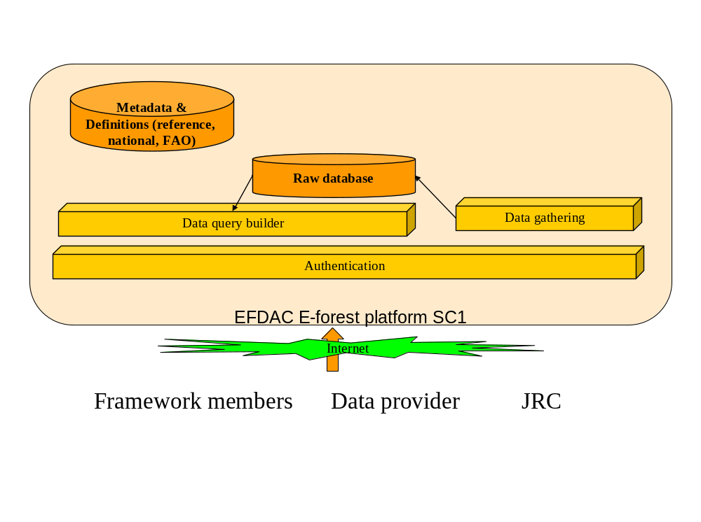.
Figure 3: SC1: consortium's platform

Database descriptions

Overview
The purpose of the database is to store raw data and provide authenticated user access to validated raw data..
This database called Raw Database has to store data compliant with metadata according to national definitions or reference definition.

A Metadata database is required to provide structured information about the data managed in the Raw Database and to offer the possibility to harmonize data.
This Metadata database is filled once with code lists, range values, flat file format, methodological aspects, table description, and updatable when needed. This Metadata database allows modules to automatically process the raw data whenever it is possible.

The Web Server Database is used to configure the web server application.

Main modules

Modules description
All modules are written in PHP language or JAVA language. Each module is composed of classes.
The database interface is written in ANSI SQL standard language (SQL 2).
Each module is self documented and a full description of all classes can be automatically generated using PHPDOC or JAVADOC.

Authentication module
The application is not accessible without authentication.
Depending on the user’s role, accesses to menu and data are possible.
Data providers can access to their own data without any restriction.
The permanent members of the consortium can access to all the data stored in the EFDAC E-forest platform.
The JRC can only access to aggregated data whenever the data are validated by the data provider.

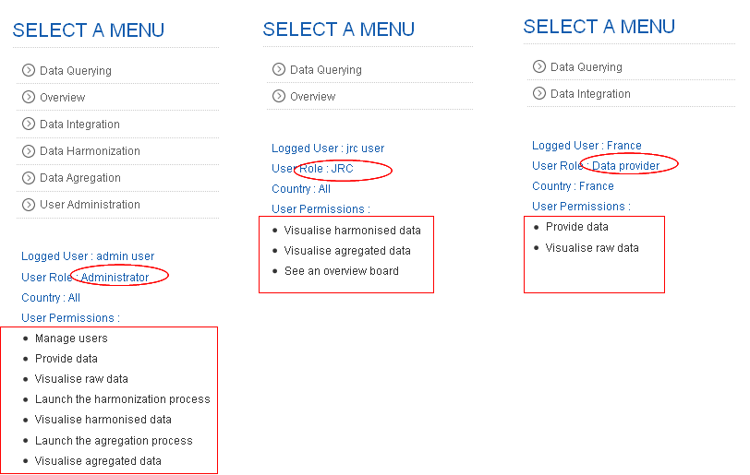

Figure 4: Authentication module

Data gathering module
This task represents the first part of the data processing. Its purpose is to ensure that the information stored in the database is “error free” and can be used in further analyses such as harmonization, aggregation,….

The files uploaded by the data provider are self documented in the user interface (see below).

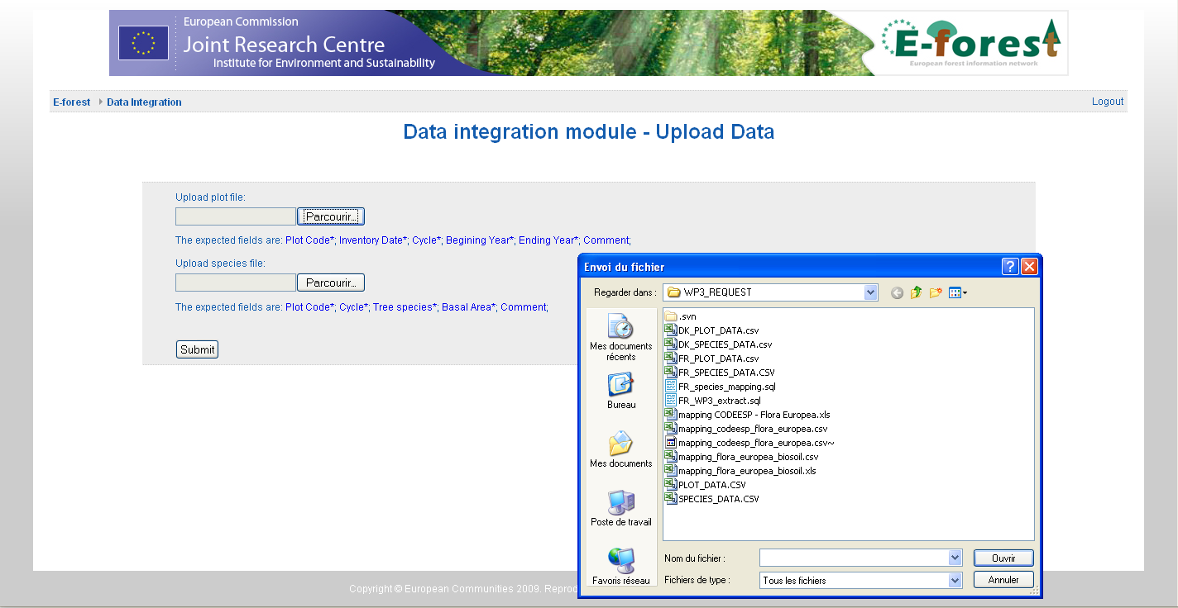

Figure 5: Data gathering module

The main part of the validation checks is based on the Metadata database and the Validation Database.
The validation checks are composed of two types of checks:
- The compliance checks verify the accordance of flat file with the formal aspects specified in the format file specifications and verify if the data are in accordance with the Metadata database (data unit, data values, ranges, etc.). If the data are not fulfilling the compliance checks, then they are marked as errors and the files are rejected.
- The conformity checks verify if the data are consistent with other data using cross-checks. These checks are only applied if the compliance checks are passed. If the data are not fulfilling the conformity checks, then they are marked as warnings.
A dedicated database called “validation database” is necessary to store all the parameter cross checks. This database is composed of the following tables:
- The CHECK table represents the knowledge database based on a list of check rules to apply to the data. It contains all information that is requiring an in-depth knowledge of the Forest environment at the European scale.
- The CHECK_ERROR table contains the results of the checks.

The various processing checks validate the data provided and ensure that only reliable and comparable data are made available for data dissemination.
Depending on the type of checks, an unsuccessful check can be considered as an error (stopping the check process) or just a warning.
In case of fatal error (compliance check only), the whole data file is rejected.
In case of warnings, the data provider is aware. The file can be corrected and resent.

Unsuccessful checks | Consequence
Compliance checks | The whole file is rejected
Conformity checks | Values are marked as Warning

Reports on the status of the transmitted data by data provider are generated automatically in response to an upload operation. The report is produced instantly through the web application.
The report contains administrative aspects:
- Data provider id,
- submission date,
and all technical aspects that can help the data provider to follow up its check operations:
- compliance results
- conformity results (only when compliance checks are successful)
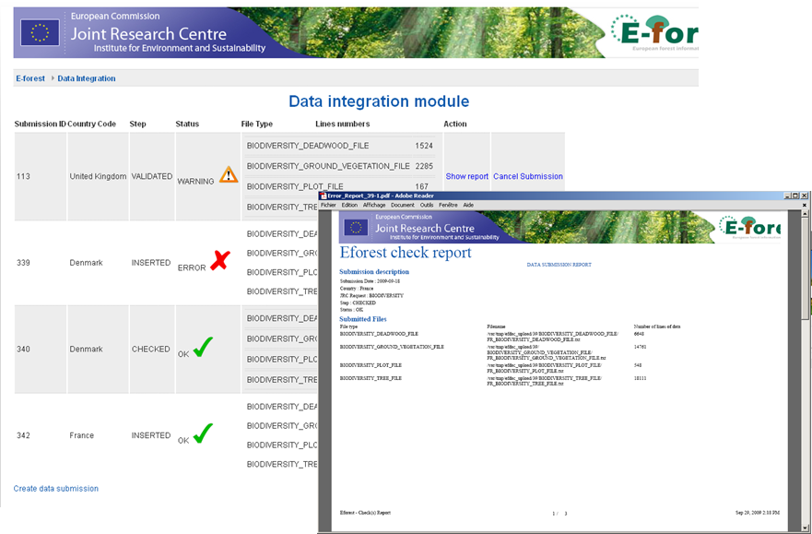

Figure 6: check report

The data provider has the opportunity to download the PDF report in order to check then correct the wrong data. Thus, the same files could be submitted several times, without any restrictions
When the data are validated (submit action), the data provider won’t be able to upload another time the same files (same request type, same year)

Data query builder
The purpose of this module is to offer the possibility to the final user to have access to the uploaded data and aggregated data in order to:
  - Check the uploaded data
  - Validate the data (uploaded or transformed)
  - Extract the data
  - Provide results
This module is used by the JRC to have access to the aggregated that have been validated by the country.

Thank to this module, te user can carry out his own request in a friendly way.
The user can specify criteria such as temporal, spatial, qualitative or quantitative criteria.
The user can also select the columns to display

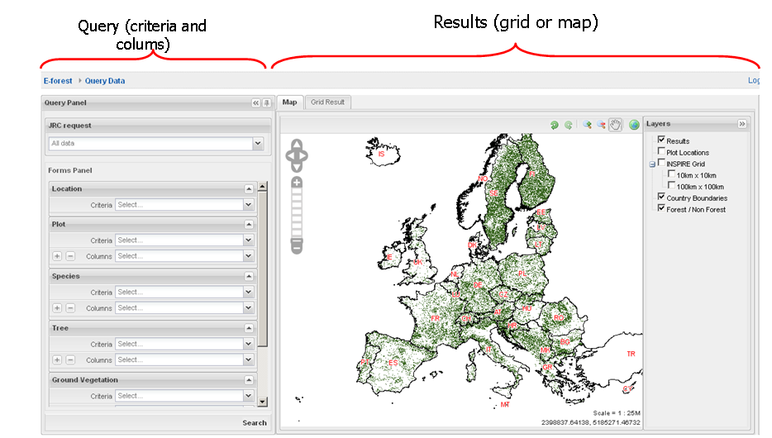

Figure 7: data query builder screenshot
Depending on the JRC request, the forms panels are adapted and filled with the corresponding metadata.
On the left side of the screen, for each panel such as location, plot, Species, etc..the user can choose the columns to be screened. He can also restricted the query by adding criteria and by selecting a specific value. The query can also be restricted using temporal criteria or spatial criteria to limit the query to a polygon drawn by the user.

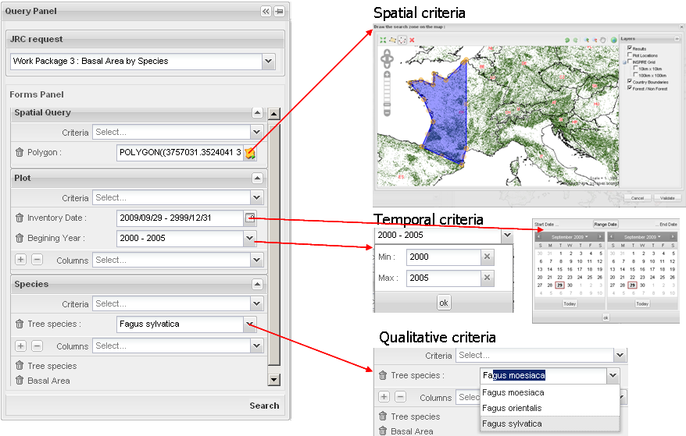

When the query is fully prepared, the user can run it.
The result of the query can be a table with all the columns selected.

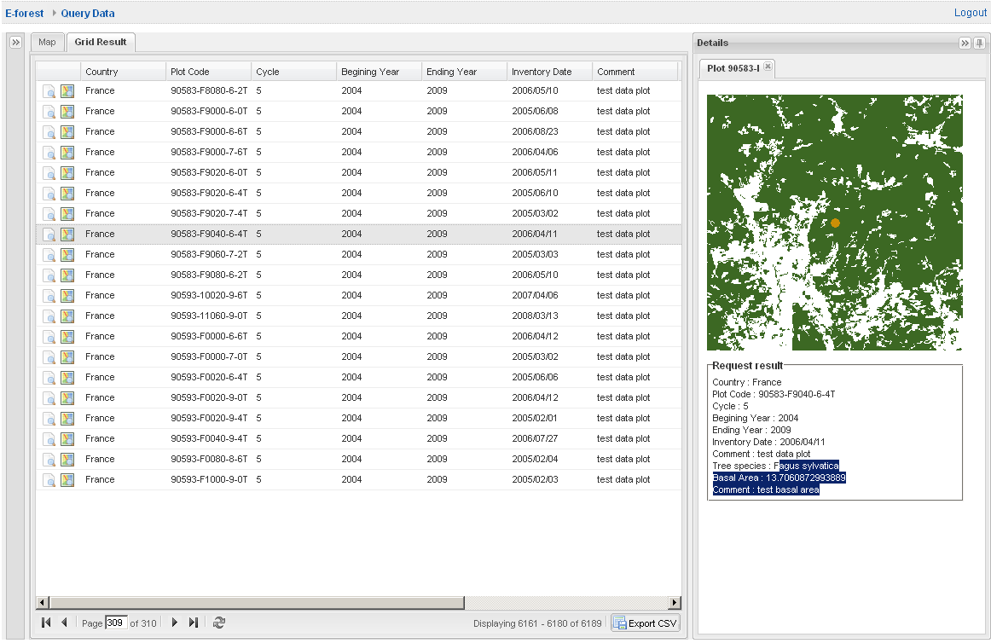
Figure 8: data query builder, table result

The content of the table can be exported in CSV format.

The user can also ask the system to build dynamically a map representation corresponding to the table content.
This map shows the localisation of the plots corresponding to the lines in the table
In this map each line is represented by a plot point
This module is useful to overview all the data or to focus on specific topic or specific specie.

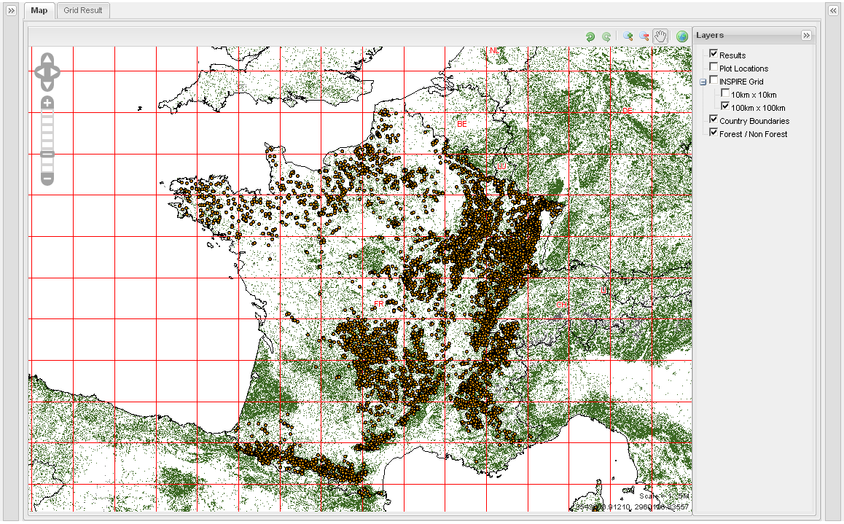
Figure 9: data query builder, map result

Follow up of the project, contractual steps

The foreseen planning presented during the kick off meeting was globally respected along the project.

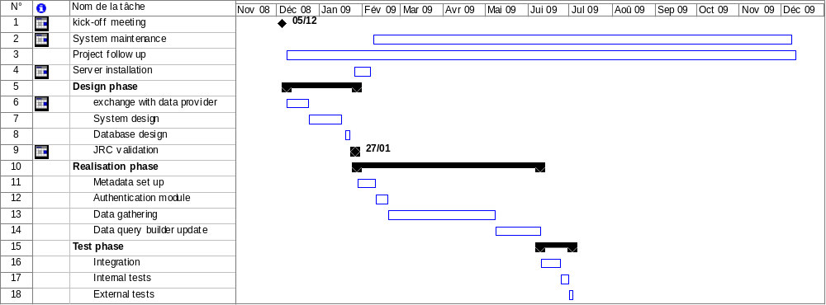

The main dates of the project are sum up below:
- 05/12:2008: kickoff meeting (contractual meeting)
- 23/01/2008: specification sent to the JRC (informal deliverable)
- 16/02/2009: progress meeting (informal meeting)
- 09/04/2009: installation of the server sent by the JRC
- 06/08/2009: demonstration of the E-forest platform
- 10/09/2009: final meeting, validation of the E-forest platform (contractual meeting)
- 20/10/2009: E-forest platform is opened for data submission
- 23/10/2009: final report (this document) sent to the JRC (contractual deliverable)

